INFO6350 Smartphones Project Report Janhavi Parulekar

**Project Name:**

‘eVite’ ..a quick way to party

**Project Overview:**

The project provides a common platform for all on going event invitations, thus successfully replacing the variety of social medias

**Technologies Used:**

Firebase authentication, Firebase Storage and Database, JSQMessagesViewController

**Software Specification:**

Xcode 9.2, Swift 4, IOS 11.2

**Objective:**

The project aims in developing a new commons platform for invitations. That way one need not hop on variety of social media platforms

**Features:**

* Creating and Advertising of events
* Discussion Board
* Real time Updates to events

**Application Flow:**

* User logs in to the application.
* If the user is not registered with the application the one can simply create an account.
* Once the account is created the user is free to take benefits of all the functionalities.
* Functionalities includes creating and publishing of their own events.
* Visual access to all the events posted by co-users

**Application Snapshots:**

First Screen (i.e. Login and Account Creation)

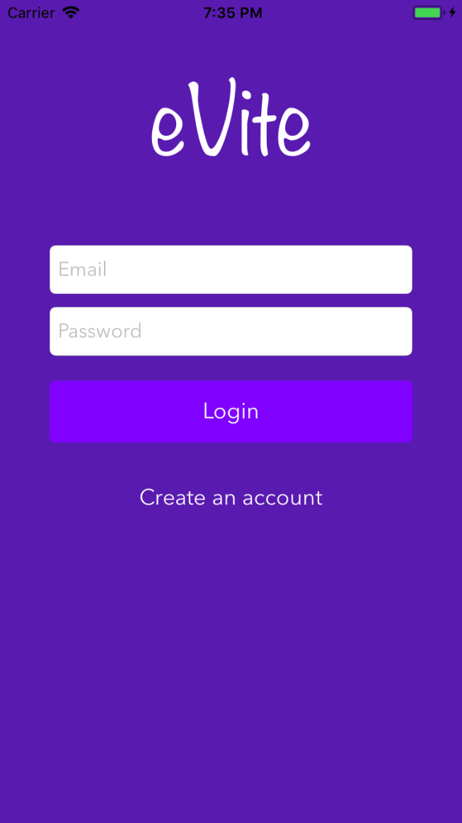 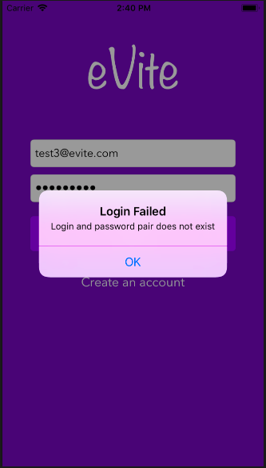 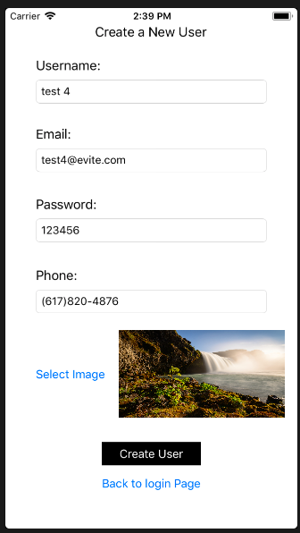

Main Screen (The Table for event Display and Detail view)

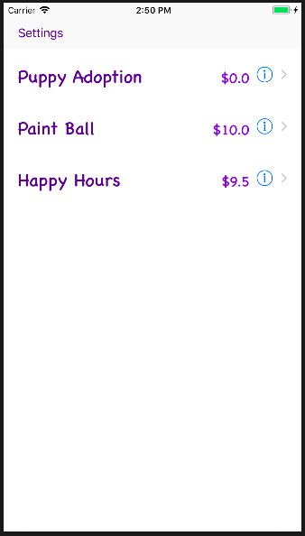 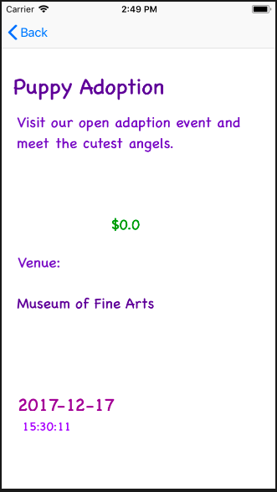

Event Creation and Discussion Board

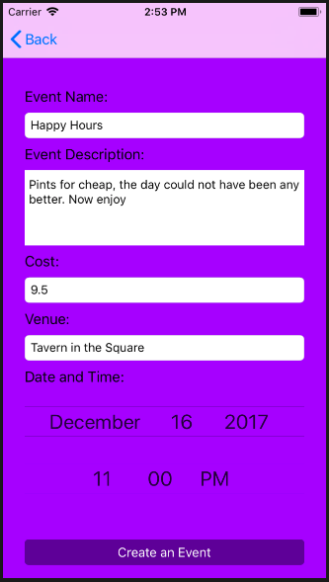 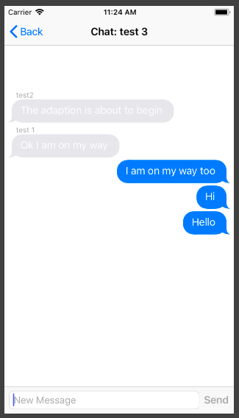

**Conclusion:**

Application can make conversation smoother and better. Now it is easier to manage the events even with busy life. One platform makes it convenient for the user to communicate with other users. Discussion board avoids the whole one to one conversational repetition.

**Future Scope:**

* We can implement event registration to guarantee booking and availability for the event
* We can implement payment feature to directly make reservations for the events
* Events can be further categorized into different categories to assist user find events that interest him
* We can specialize discussion boards based on events